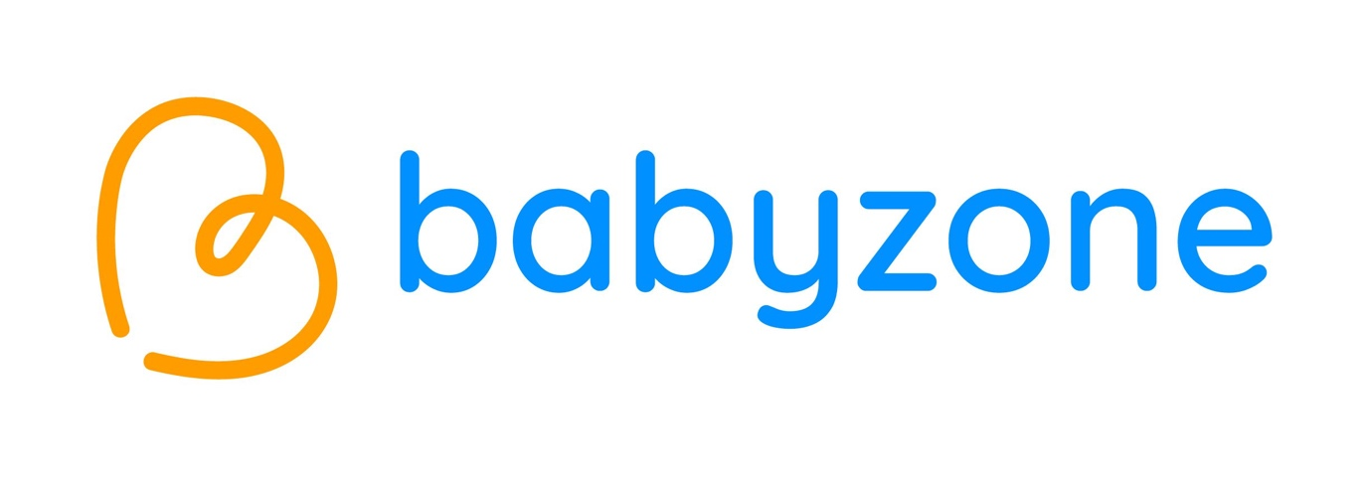
Safeguarding and Child Protection Policy

Policy Date: September 2026
Review Date: September 2027
Contents
Section |  | Page
Section 1: Introduction |  | 2
Section 2: Purpose and Aims |  | 3
Section 3: Our Legal Responsibilities |  | 5
Section 4: Safer Recruitment |  | 5
Section 5: Child Protection Procedures |  | 6
Section 5: | 5.1: Responsible Persons | 6
Section 5: | 5.2: Concern from something the child says | 6
Section 5: | 5.3: Young parents under the age of 18 | 7
Section 5: | 5.4: Parental Mental Health as a Safeguarding Indicator | 7
Section 5: | 5.5: Extra-Familial Harm and Harm Outside the Home | 8
Section 5: | 5.6: Pre-Birth Safeguarding | 8
Section 6: The Role of the Designated Safeguarding Lead (DSL) |  | 8
Section 7: Allegations involving staff, volunteers or partnership workers |  | 11
Section 8: Whistleblowing |  | 12
Section 9: Respectful Conduct and Zero Tolerance of Abuse |  | 13
Section 10: Digital Family Membership and Data Protection |  | 13
Section 11: Digital Safeguarding Concern Recording (MyConcern) |  | 13
Section 12: Confidentiality of Information |  | 14
Appendix A: Types of abuse and signs of abuse |  | 15-21
Appendix B: Safeguarding and child protection flow chart: What to do if you become aware of a safeguarding issue |  | 22
Appendix C: Key contact details for safeguarding and child protection |  | 23
Appendix D: Child Protection/Family Welfare Concern Reporting Form |  | 24

Section 1: Introduction
At Babyzone the safety and welfare of children is of the utmost importance. We are committed to safeguarding and protecting all children and understand that this is the responsibility of everyone. We will give equal priority to keeping all children safe regardless of their age, disability, gender, race, religion or belief. We also recognise that some children are additionally vulnerable because of the impact of discrimination, previous experiences, their level of dependency, communication needs or other issues.
Parents/carers and families attend Babyzone with their children and remain responsible for the welfare of their children at all times. Babyzone does not undertake any activities with children in the absence of their parents/carers but does have the opportunity to observe the children’s welfare within their family context. Babyzone staff should never be alone with a child in any circumstance.
This policy applies to Babyzone Hubs located in England and reflects the English legislative and statutory framework. The key legislation is the Children Act 1989 and the operational framework is Working Together to Safeguard Children (2026).
Section 2: Purpose and Aims
The purpose of this policy is to ensure that all staff, volunteers, trustees and external agencies, including partners delivering on behalf of Babyzone are aware of their legal and personal responsibilities to ensure the safeguarding and welfare of children. Staff and volunteers in this organisation accept and recognise their duty to develop awareness of issues which cause children harm.
Babyzone’s safeguarding and child protection policy is compulsory reading for all staff, trustees and volunteers and each individual must sign to say they have read and understood the document. It is also on our website (www.babyzone.org.uk). The Designated Safeguarding Lead of each Babyzone site will keep a signed paper record from each member of their staff. The Safeguarding Lead and Safeguarding Trustee will also ensure that these records are in place.
Babyzone will review this policy annually or sooner in light of new legislation, guidance (statutory and non-statutory) and best practice in safeguarding and child protection.
There are a number of elements to this policy and the following procedures are implemented in order to uphold our duty of care:
- Ensure safer recruitment practice in checking the suitability of all our staff and volunteers to work with children
- Ensure all staff are appropriately trained
- Raising awareness safeguarding/child protection issues amongst all staff and volunteers and of what to do if they have concerns. This includes raising awareness of any current issues such as: child abduction and community safety incidents; Child Criminal Exploitation (CCE) and Child Sexual Exploitation (CSE), county lines; modern slavery; cybercrime; domestic abuse, homelessness, so-called ‘honour-based’ abuse (including Female Genital Mutilation (FGM) and Forced Marriage); preventing radicalisation; self-harm and suicidal ideation, sexual violence and sexual harassment (harmful sexual behaviour).
- Ensure that volunteers are appropriately supervised
- Ensure that all visitors to Babyzone have their DBS certificates checked where necessary and/or are appropriately supervised
- Ensure that our procedures and expectations for identifying and reporting/recording cases, or suspected cases, of abuse to relevant agencies are robust
- Ensure that our links with relevant agencies are effective and that we co-operate and work in a partnership regarding child protection matters
- Ensure we respond appropriately to any concern or allegation made about a member of staff, volunteer or partnership worker
- Ensure staff follow accepted ‘safe practice’ principles when engaging with children and their families.
In this policy a child is defined as,
“anyone who has not yet reached their 18th birthday.”
(Working Together to Safeguard Children, 2026, p5).
Safeguarding and promoting the welfare of children is defined for the purposes of this policy as:
- providing help and support to meet the needs of children as soon as problems emerge
- protecting children from maltreatment, whether that is within or outside the home, including online
- preventing impairment of children’s mental and physical health or development
- ensuring that children grow up in circumstances consistent with the provision of safe and effective care
- promoting the upbringing of children with their birth parents, or otherwise their family network4 through a kinship care arrangement, whenever possible and where this is in the best interests of the children
- taking action to enable all children to have the best outcomes in line with the outcomes set out in the Children’s Social Care National Framework5,6
  - Outcome 1: Children, young people and families stay together and get the help they need
  - Outcome 2: Children and young people are safe in and outside their homes
  - Outcome 3: Children and young people are supported by their family network
  - Outcome 4: Children in care and care leavers have stable, loving homes

(Working Together to Safeguard Children, 2026, p6).

Child protection is defined for the purposes of this policy as:
“activity that is undertaken to protect specific children who are suspected to be suffering, or likely to suffer, significant harm. This includes harm that occurs inside or outside the home, including in foster care and residential care, as well as online. Effective safeguarding is anti-discriminatory and antiracist. Practitioners should understand and be sensitive to factors, including economic and social circumstances, ethnicity and disability, which can impact children and families’ lives.”
(Working Together to Safeguard Children, 2026, p7).

Online Safety
Although Babyzone does not carry out online sessions with families or provide digital devices for children, staff and volunteers must remain aware of safeguarding risks that arise online. This includes risks linked to social media, online grooming, radicalisation and the sharing of images. Staff must not communicate with families or children via personal social media or messaging platforms. Any online safeguarding concern disclosed by a parent or observed by staff must be reported to the DSL in line with this policy.

Digital Family Membership
- From September 2026, families attending Babyzone register once for a digital family membership.
- The membership record supports safeguarding by giving staff a reliable, consistent way of confirming who is attending with a child and cross-checking this against the family's profile.
- Registration and check-in remain staff-assisted at every visit. The system speeds up the welcome interaction, it does not replace direct staff engagement with the family and ownership of a smartphone or digital wallet is never mandatory. Families without a card, phone or digital confidence are checked in via manual lookup, reaching the same family record.

Section 3: Our Legal Responsibilities
“Nothing is more important than children’s welfare. Every child deserves to grow up in a safe, stable, and loving home. Children who need help and protection deserve high quality and effective support. This requires individuals, agencies, and organisations to be clear about their own and each other’s roles and responsibilities, and how they work together.”
(Working Together to Safeguard Children, 2026, p7)
The Children Act (1989) makes it clear that people who work with children have the responsibility to keep them safe. This is supported by the United Nations Convention on the Rights of the Child (to which the UK is a signatory) which sets out the rights of children to be free from abuse. The document 'Working Together to Safeguard Children (2026)’ sets out the arrangements for how all organisations must work together to safeguard and promote the welfare of children.
Section 4: Safer Recruitment
The safe recruitment of staff at Babyzone is the first step in safeguarding and promoting the welfare of children.
In our recruitment and selection of staff and volunteers we will at all times adhere to the government guidance contained within ‘Working Together to Safeguard Children (2026).’
We will ensure that:
- For good practice, our interview panel includes at least one member who has completed safer recruitment training
- For all posts, paid and voluntary, the appropriate Disclosure and Barring Service (DBS) information has been received
- All new members of staff or volunteers are made familiar with Babyzone’s policies and procedures including the safeguarding and child protection policy. They will be asked to sign to confirm that they have read, understood and will adhere to the policy. The Designated Safeguarding Lead of each Babyzone site will keep a signed copy of the policy from each member of staff and the Safeguarding Officer and Safeguarding trustee will also ensure that these records are in place.

Please also see the Babyzone Safer Recruitment Policy.
Section 5: Child Protection Procedures
If you believe a child is at immediate risk of harm, call 999
It is not the individual staff member, volunteer or partnership worker’s role to investigate suspected abuse, but it is their responsibility to recognise it and report it as appropriate to the Designated Safeguarding Lead.
When you become aware there is a safeguarding issue;
Do not delay
- Tell the Designated Safeguarding Lead as soon as you can (See Appendix C for DSL information and Key contact details)
- If the DSL is not available, staff should take advice from the local safeguarding support organisation or if it is an emergency, the police should be called immediately
- Early referral gives more time to offer help to the child and family before the situation becomes more serious
- When the matter is already severe or serious, early referral gives more time for others to protect the child
- The Designated Safeguarding Lead may also consult the local safeguarding support organisation.
Make a written record
- At the earliest opportunity make a written record of your concerns, record facts accurately and do not express opinion. These notes will help to ensure accuracy in recalling events later. Notes should be legible, signed and given a date and time. Do not use audio to record disclosures. The ‘Child Protection/Family Welfare Concern Reporting Form’ (Appendix. D) can be used for the purpose of making immediate, ‘in the moment’ notes.
- Do not take photographs of any physical injuries but you can make a record of locations on a body map.
- Any original notes must be given to the Designated Safeguarding Lead as soon as possible and kept.
- The immediate handwritten record described here is the first step and is subsequently logged in MyConcern by the DSL as the permanent, secure record.
5.1: Responsible Persons
Each Babyzone hub has a Designated Safeguarding Lead, usually the Head of the Babyzone, and one Deputy Designated Safeguarding Lead.
The Designated Organisational Lead for Safeguarding at Babyzone is Jessica Barnaschone. (jessica@babyzone.org.uk)
The lead Trustee for Safeguarding at Babyzone is Paddy Radcliffe. (paddy@impactorganisations.com)
The Safeguarding Trustee provides independent oversight of Babyzone’s safeguarding arrangements. Their responsibilities include ensuring that appropriate policies and procedures are in place, confirming that safeguarding training is completed by all staff and volunteers, and monitoring the effectiveness of safeguarding practice across Babyzone. The Safeguarding Trustee also works closely with the Designated Safeguarding Lead (DSL) to ensure that safeguarding concerns and referrals are handled promptly, appropriately, and in line with statutory guidance.
5.2: Concern from something the child says
At Babyzone, we do not undertake activities with children in the absence of their parents/carers but there may be times when a child approaches a member of staff and a concern is raised from something they have said.
- Listen - do not ask questions or interrogate the child
- Remain calm - if you are shocked, upset or angry the child will sense this and this could stop them from saying more
- Reassure – the child has done nothing wrong - tell them that it is alright to talk
- Do not promise to keep it secret - tell the child that you will have to tell someone else who will be able to give help and advice
5.3: Young parents under the age of 18
We recognise that when working with young parents under 18, both the parent and the infant are children under the law, requiring a dual-welfare approach to early help and protection.
Young parents are very welcome at Babyzone. As defined previously within this policy, a child is anyone who has not yet reached their 18th birthday and so there are sometimes young parents attending Babyzone who are considered children themselves. If you become aware of a safeguarding issue involving a young parent, it must be treated in the same way as any other child safeguarding concern and the same procedures must be followed. The Designated Safeguarding Lead will encourage the young parent to cooperate in the safeguarding referral process if appropriate (please see the section below on Gaining personal details to make a referral for further information.)
5.4: Parental Mental Health as a Safeguarding Indicator
Given that Babyzone works with families from pregnancy onwards, staff may encounter parents or carers experiencing significant mental health difficulties, including perinatal mental illness. Where a parent or carer’s mental health is causing concern regarding the welfare of their child, this must be treated as a potential safeguarding matter. Staff should:
- Report any such concerns to the DSL promptly.
- Treat the family with sensitivity and without judgement, remembering that the welfare of the child is the primary consideration.
- Not attempt to diagnose or assess the parent’s mental health, but describe observed behaviours and concerns factually in any written record.
5.5: Extra-Familial Harm and Harm Outside the Home
Babyzone recognises that children can be at risk of harm not only within the family home but also outside it, in the community, online or in other settings. This is referred to as extra-familial harm and may include child criminal exploitation, child sexual exploitation, county lines, online grooming and radicalisation. Where any concern arises that a child may be experiencing harm outside their home, the DSL will consider the context in which harm may be occurring, including online, when deciding how to respond. Staff and volunteers should be alert to signs that a child may be experiencing harm in extra-familial contexts.
5.6: Pre-Birth Safeguarding
Because Babyzone works with families from pregnancy onwards, staff may encounter expectant parents who give rise to safeguarding concerns. In line with Working Together to Safeguard Children (2026), the needs of unborn children should be considered where there are concerns about whether a parent or carer will be able to provide safe and suitable care following birth. Any such concerns must be reported to the DSL, who will consider whether a referral to the local authority is appropriate.
Section 6: The role of the Designated Safeguarding Lead (DSL)
The Designated Safeguarding Lead has a responsibility for Safeguarding and Child Protection. Their duties are outlined below:
Manage referrals
The Designated Safeguarding Lead (DSL) will refer cases:
- of suspected abuse and neglect to the local authority safeguarding partnership department as required
- to the Channel programme (a confidential, voluntary multi-agency safeguarding programme that supports people who are vulnerable to radicalisation) where there is a radicalisation concern as required
- where a person is dismissed or has left due to risk/harm to a child to the Disclosure and Barring Service as required; and
- where a crime may have been committed to the Police as required.
When the DSL of each Babyzone Hub logs a concern on MyConcern, the Safeguarding Lead will be notified automatically through the system. The DSL at Babyzone will also inform the Designated Safeguarding Lead at the corresponding host venue of any safeguarding concerns raised and any referrals made, where appropriate.
Gaining personal details to make a referral
Wherever possible, the Designated Safeguarding Lead's first approach will always be to talk to the family privately, alongside another member of staff, to offer support, build a relationship of trust and gain the personal details required for a referral directly from the family, along with their consent to make the referral.
The following personal details are required to make a successful referral:
- Full names (of adult and child/ren)
- Date of birth (of adult and child/ren)
- Address (of adult and child/ren)
Where a family has registered for Babyzone's digital family membership, some or all of these details may already be held on the family's membership record. If a family is unwilling or unable to share their personal details directly, the Designated Safeguarding Lead may use the details held on the family's digital membership record in order to progress a referral where the level of concern requires it.
Working with others
The Designated Safeguarding Lead (DSL) will:
- act as a source of support, advice and expertise for all staff
- act as a point of contact with the safeguarding partners
Information sharing and managing the child protection file
The Designated Safeguarding Lead is responsible for ensuring that child protection files are kept up to date. Child protection files are held securely within MyConcern.
Records will include:
- a clear and comprehensive summary of the concern including dates
- details of how the concern was followed up and resolved
- a note of any action taken, decisions reached and the outcome
The file will only be accessed by those who need to see it. All records must be stored and retained in line with the Babyzone Data Protection Policy and the Data Retention Schedule.
Raising Awareness
The Designated Safeguarding Lead (DSL) will:
- ensure each member of staff and volunteer has access to, and understands Babyzone’s safeguarding and child protection policy and procedures, especially new staff
- ensure Babyzone’s safeguarding and child protection policy is reviewed annually (as a minimum) and the procedures and implementation are updated and reviewed regularly
- ensure the safeguarding and child protection policy is available publicly
- link with the safeguarding partners to make sure staff are aware of any training opportunities and the latest local policies on local safeguarding arrangements
Training, knowledge and skills
The Designated Safeguarding Lead (DSL) will undergo training to provide them with the knowledge and skills required to carry out the role. The DLS will undertake Prevent awareness training (The Prevent strategy, published by the Government in 2011 (updated 2023), is part of our overall counter-terrorism strategy, CONTEST. The aim of the Prevent strategy is to reduce the threat to the UK from terrorism by stopping people becoming terrorists or supporting terrorism.)
Training should provide DSLs with a good understanding of their own role, how to identify, understand and respond to specific needs that can increase the vulnerability of children, as well as specific harms that can put children at risk, and the processes, procedures and responsibilities of other agencies.
- understand the importance of the role the Designated Safeguarding Lead has in providing information and support to safeguard and promote the welfare of children.
- understand the importance of information sharing, both within Babyzone and with the safeguarding partners, other agencies and relevant organisations
- obtain access to resources and attend any relevant or refresher training courses
- encourage a culture of listening and being observant amongst all staff and volunteers
Training Requirements

All Babyzone staff, class leaders, volunteers and members of the senior leadership team must complete safeguarding and child protection training appropriate to their role. This training is renewed at least every two years, with more frequent safeguarding updates (usually weekly) provided to ensure everyone remains informed about new risks, local procedures, and changes to statutory guidance.
The Designated Safeguarding Lead will complete more advanced safeguarding training at least every two years.
Providing support to staff
Training will support the Designated Safeguarding Lead in developing expertise, so they can support and advise staff and help them feel confident on welfare, safeguarding and child protection matters. This includes specifically to ensure that staff are supported during the referral process.
Holding and sharing information
The Designated Safeguarding Lead will be equipped to:
- understand the importance of information sharing, both within Babyzone, and with safeguarding partners, other agencies and organisations
- understand relevant data protection legislation and regulations, especially the Data Protection Act 2018 and the UK General Data Protection Regulation (UK GDPR); and
- be able to keep detailed, accurate, secure written records of concerns and referrals and understand the purpose of this record-keeping
The Data Protection Act 2018 and UK GDPR do not prevent the sharing of information for the purposes of keeping children safe. Fears about sharing information must not be allowed to stand in the way of the need to safeguard and promote the welfare and protect the safety of children.
Section 7: Allegations involving staff, volunteers or partnership workers
Allegations or concerns made about a member of staff, volunteer or any partnership worker must immediately be notified to the Designated Safeguarding Lead. However, if the Designated Safeguarding Lead is implicated in the concerns, the staff member, volunteer or partnership worker should discuss the concerns directly with the Local Authority Designated Officer (LADO), using the reporting channels detailed in Appendix B.
This guidance should be followed where it is alleged that anyone working at Babyzone has:
- behaved in a way that has harmed a child, or may have harmed a child and/or;
- possibly committed a criminal offence against or related to a child and/or;
- behaved towards a child or children in a way that indicates he or she may pose a risk of harm to children; and/or
- behaved or may have behaved in a way that indicates they may not be suitable to work with children.
The Designated Safeguarding Lead will always consult the Local Authority Designated Officer (LADO) within one working day (contactable through the Children’s Services - see Appendix B). The LADO will advise on the investigation and involve other agencies as appropriate. Do not commence an internal investigation before consulting the LADO.
Following consultation, the Designated Safeguarding Lead will decide on appropriate action, which may include consideration of disciplinary proceedings. It is important to bear in mind that although the concern may relate to an individual child, other children may also be at risk.
Allegations and concerns about staff are recorded in MyConcern's separate staff safeguarding module.
Babyzone will promote an open and transparent culture in which all concerns about all adults working in or on behalf of Babyzone (including volunteers and partnership workers) are dealt with promptly and appropriately. This should encourage an open and transparent culture; enabling Babyzone to identify concerning, problematic or inappropriate behaviour early; minimise the risk of abuse; and ensure that adults working in or on behalf of Babyzone are clear about professional boundaries and act within these boundaries, and in accordance with the ethos and values of the charity.

Section 8: Whistleblowing
All staff, trustees, volunteers and partnership workers at Babyzone should feel able to raise concerns about poor or unsafe practice and potential failures in Babyzone’s safeguarding systems and know that such concerns will be taken seriously.
A whistleblowing disclosure must be about something that affects the general public such as:
• a criminal offence has been committed, is being committed or is likely to be committed • a legal obligation has been breached
• there has been a miscarriage of justice
• the health or safety of any individual has been endangered
• there has been risk or actual damage to the environment
• you believe someone is covering up a wrongdoing
Where a staff member feels unable to raise an issue directly with Babyzone, or feels that their genuine concerns are not being addressed, other whistleblowing channels may be open to them:
The NSPCC whistleblowing helpline is available as an alternative route for staff that do not feel able to raise concerns regarding child protection failures internally or have concerns about the way a concern is being handled by Babyzone.
Staff can call 0800 028 0285 – line is available from 8:00am to 8:00pm, Monday to Friday or email: help@nspcc.org.uk.
Section 9: Respectful Conduct and Zero Tolerance of Abuse
Babyzone is committed to maintaining a calm, respectful, and nurturing environment for all families, babies, staff, volunteers and visitors. As part of our safeguarding responsibilities, we operate a zero-tolerance approach to any form of abusive behaviour towards staff and volunteers.
All members of the Babyzone team have the right to feel safe and supported while carrying out their duties. Abuse in any form compromises the safety of the space and the wellbeing of babies and families.
Abusive behaviour includes, but is not limited to:
- Verbal abuse: shouting, swearing, intimidating behaviour, aggressive tone, threats, or discriminatory comments.
- Physical abuse: aggressive gestures, unwanted physical contact, attempts to intimidate physically, or any actions that place staff or volunteers at risk of harm.
Where abusive behaviour occurs:
- The individual will be asked to leave the Babyzone session or the building immediately. In lower-level situations (e.g., raised voice without aggression), the staff member may first request that the behaviour stops, depending on professional judgement and risk.
- Depending on the severity of the incident, short-term or permanent exclusion from Babyzone may be implemented.
- Serious incidents will be managed in line with the Babyzone Safeguarding and Critical Incident Procedures (including Code Amber and Code Red responses) and may be escalated to external agencies, including the police.
Raising a Concern with the Designated Safeguarding Lead (DSL)
- Any staff member or volunteer who witnesses or experiences abusive behaviour from a parent, carer, visitor, or any individual within the Babyzone environment must report this to the Designated Safeguarding Lead (DSL) as soon as possible. Concerns can be raised verbally at the time of the incident, followed by a written record using Appendix D: Child Protection/Welfare Concern Reporting Form. Appendix D remains the paper form used to capture the concern at the time (including as an offline fallback if MyConcern is unavailable and is then logged into MyConcern by the DSL.
- The DSL will review the information, assess the level of risk, and take appropriate action in line with the Babyzone Safeguarding Policy and Critical Incident Procedures. Where the DSL is unavailable, concerns should be escalated to the Deputy DSL or a member of the Babyzone Management Team.
All staff and volunteers have a responsibility to share safeguarding concerns promptly so that risks can be appropriately managed and the safety of staff, families, and babies is maintained.
Section 10: Digital Family Membership and Data Protection
From September 2026, families attending Babyzone register for a digital family membership, replacing manual sign-in. Each family receives a QR-based membership card, and staff use this, or a manual lookup by name, postcode or email where a family has no card, phone, or digital confidence, to check families in on arrival.
The system supports safeguarding by giving staff a consistent, reliable way of confirming who has arrived with a child and cross-checking this against the family's registered record. It does not change the fundamental safeguarding expectations set out elsewhere in this policy: staff must engage directly with every family at every visit, and the digital process speeds up this interaction rather than replacing it. Ownership of a smartphone or digital wallet is never mandatory and assisted check-in remains available to every family.
Personal data captured through the digital membership system, including carer and child names, contact details, postcode, date of birth, and attendance history, is subject to the same Data Protection Act 2018 and UK GDPR obligations set out in Section 11 (Confidentiality of information) and access is restricted on a role-based basis to those who need it for safeguarding or operational purposes.
Section 11: Digital Safeguarding Concern Recording (MyConcern)
From September 2026, Babyzone uses MyConcern, a secure digital safeguarding case management system, to record and manage safeguarding concerns, referrals and outcomes across the Babyzone hub network.
MyConcern provides a single, centralised, access-controlled record for each concern. This supports the DSL's responsibilities under Section 6 (Information sharing and managing the child protection file) by keeping concern records secure, consistent and easy to retrieve where a safeguarding history needs to be reviewed or shared with external agencies.
Access levels within MyConcern:
- Level 1 - Organisational oversight: The Designated Organisational Lead for Safeguarding, CEO and Safeguarding Trustee, with full visibility across all hubs, including all concern records, staff safeguarding allegations, and community reports.
- Level 2 - Hub-level safeguarding leads: Heads of Babyzone/DSLs and Deputy DSLs, with access to record, manage and close concerns relating to their own hub.
- Level 3 - Staff and class leaders: Able to raise a new concern on the system, but without wider access to other concern records or case histories.
Staff safeguarding concerns and allegations
Concerns, low-level concerns and self-referrals relating to Babyzone staff, volunteers or partnership workers (see Section 7) are recorded in a separate, restricted-access area of MyConcern, kept apart from concerns relating to children and families.
Community reporting
MyConcern also provides a QR code and web-link reporting route, allowing parents, carers and the wider Babyzone community to raise a safeguarding or wellbeing concern directly. Where a report is made this way without the reporter's contact details, the DSL will assess what can reasonably be done with the information provided; a report that cannot be linked to an identifiable child or situation may limit Babyzone's ability to follow up directly; but all reports will still be reviewed and considered by the DSL and used to identify wider patterns or concerns about the Babyzone environment.
Where a concern is raised verbally or in person, staff should continue to follow the immediate steps in Section 5 (tell the DSL without delay, make a written record). That written record is then entered into MyConcern by the DSL as the permanent record.
Section 12: Confidentiality of information
The children and families who attend Babyzone have the right to expect that all staff will deal sensitively with their situation. It is important that information is only available to those who need to know it and will have gained written and recorded permission from the DLS to do so. Safeguarding/Child Protection issues relating to individual cases must not be subject to open discussion amongst Babyzone staff.
All personally identifiable information will be kept securely, following Babyzone’s obligations under the latest Data Protection Act in England (2018) and the General Data Protection Regulations (GDPR) set out by the European Union.
Members of staff should also remember not to promise to keep any ‘secrets’ for children or families who make a disclosure.
Appendix A: Types of abuse and signs of abuse
Appendix B: Safeguarding and child protection flow chart: What to do if you become aware of a safeguarding issue
Appendix C: Key contact details for safeguarding and child protection
Appendix D: Child Protection/Family Welfare Concern Reporting Form

Appendix A: Types of abuse and signs of abuse
Abuse - A form of maltreatment of a child. Somebody may abuse or neglect a child by inflicting harm, or by failing to act to prevent harm. Harm can include ill treatment that is not physical as well as the impact of witnessing ill treatment of others. This can be particularly relevant, for example, in relation to the impact on children of all forms of domestic abuse. Children may be abused in a family or in an institutional or community setting by those known to them or, more rarely, by others. Abuse can take place wholly online, or technology may be used to facilitate offline abuse. Children may be abused by an adult or adults, or another child or children.
Knowing what to look for is vital to the early identification of abuse and neglect. All staff and volunteers should be aware of indicators of abuse and neglect so that they are able to identify cases of children who may need help or protection. All staff and volunteers should be aware that abuse, neglect and safeguarding issues are rarely stand-alone events that can be covered by one definition or label. In most cases, multiple issues will overlap with one another.
What follows are the definitions of abuse and types of abuse.
Please note that these lists are not exhaustive.
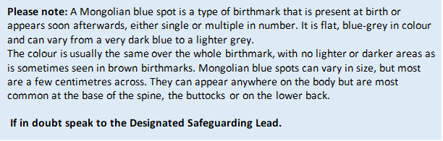
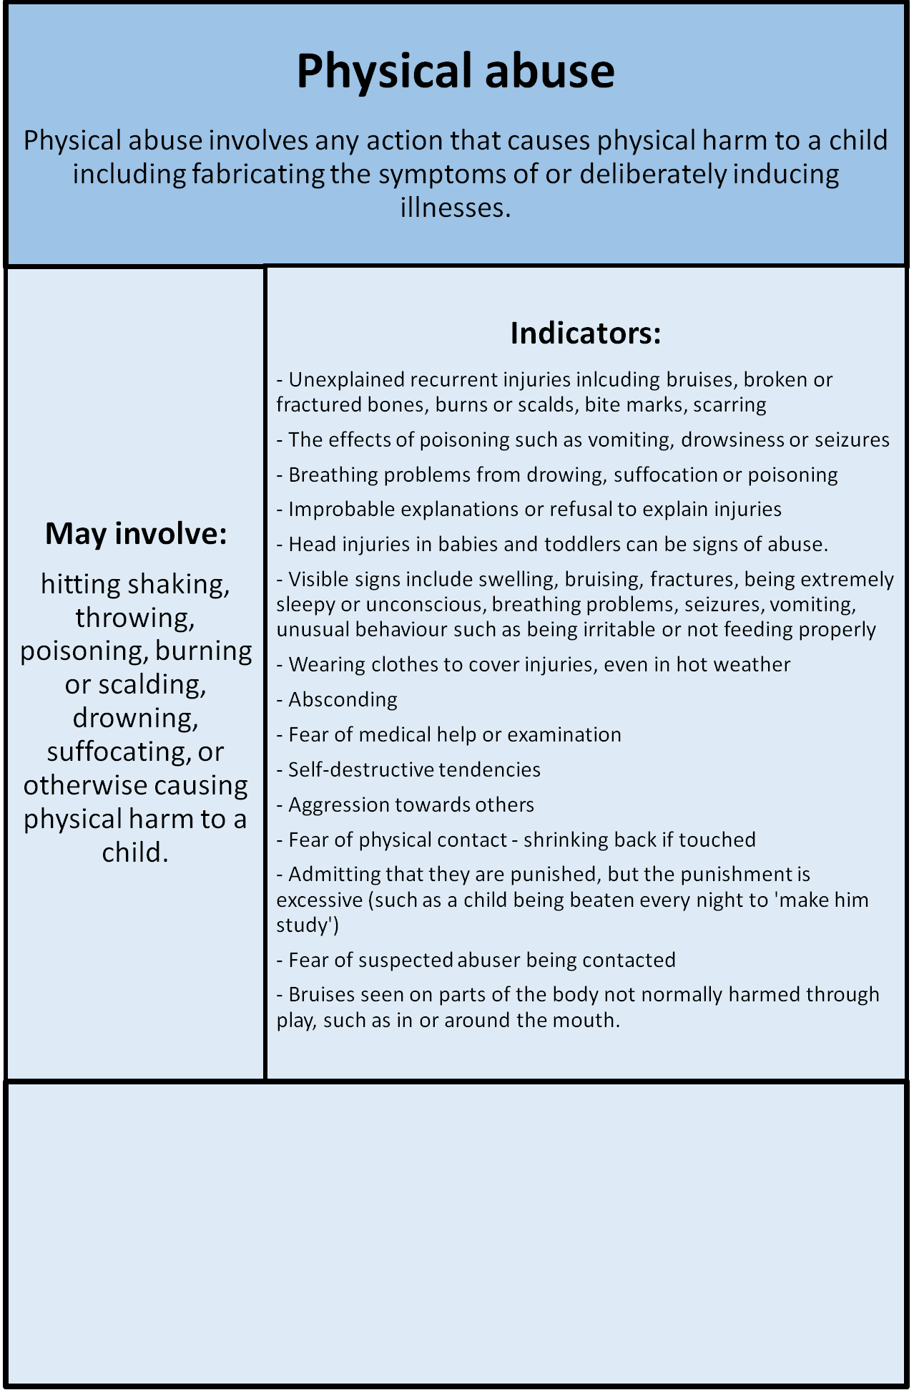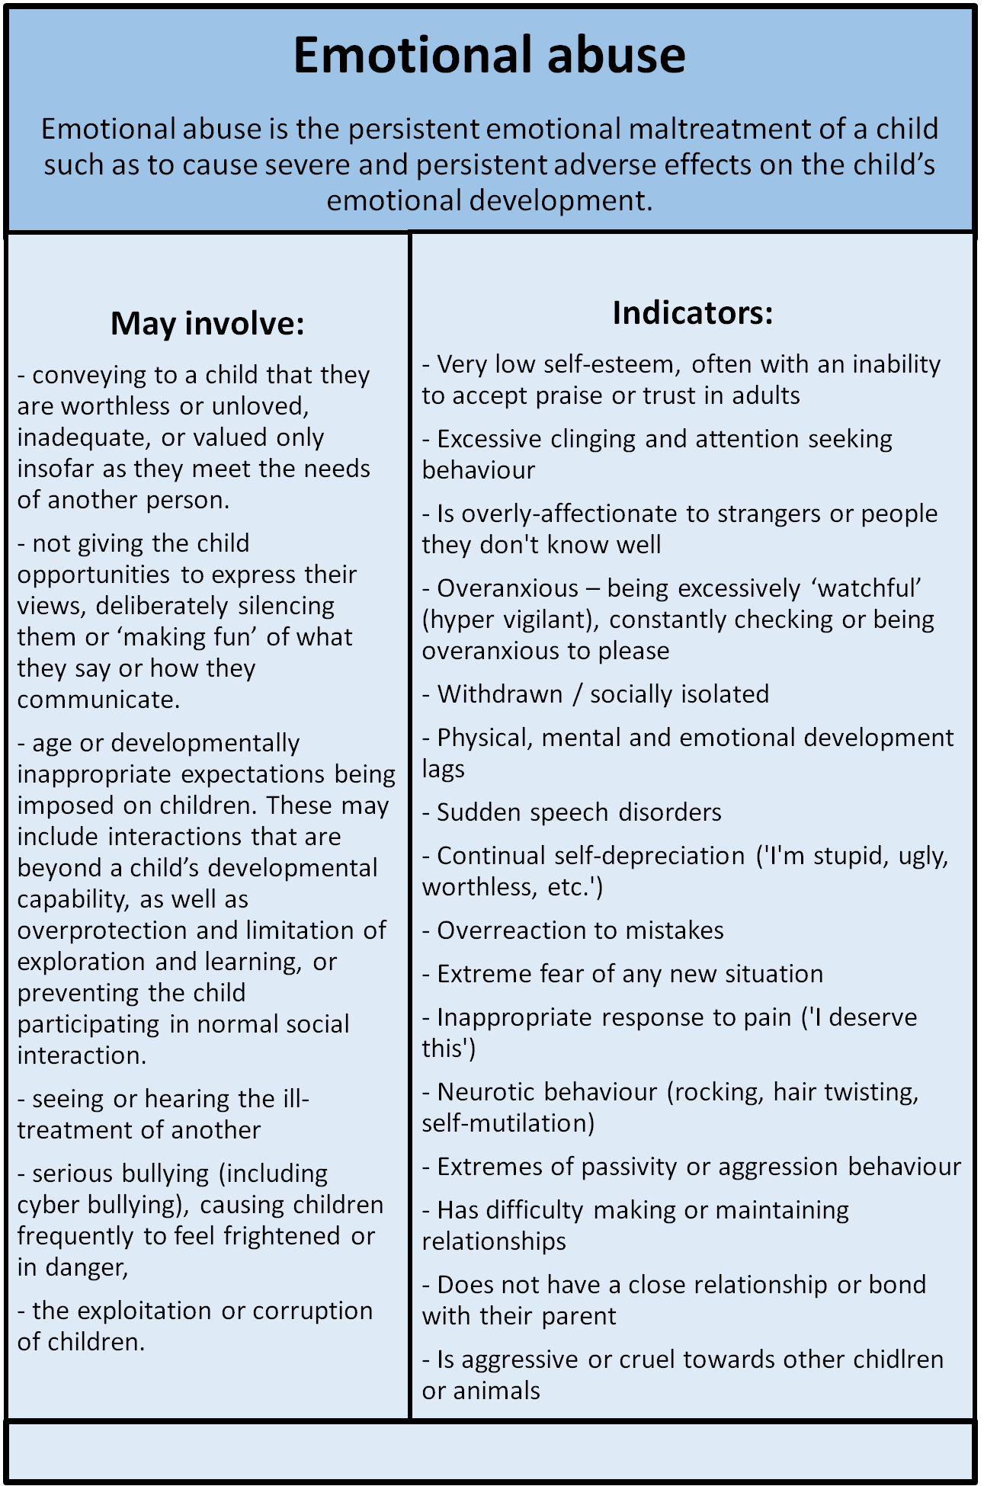
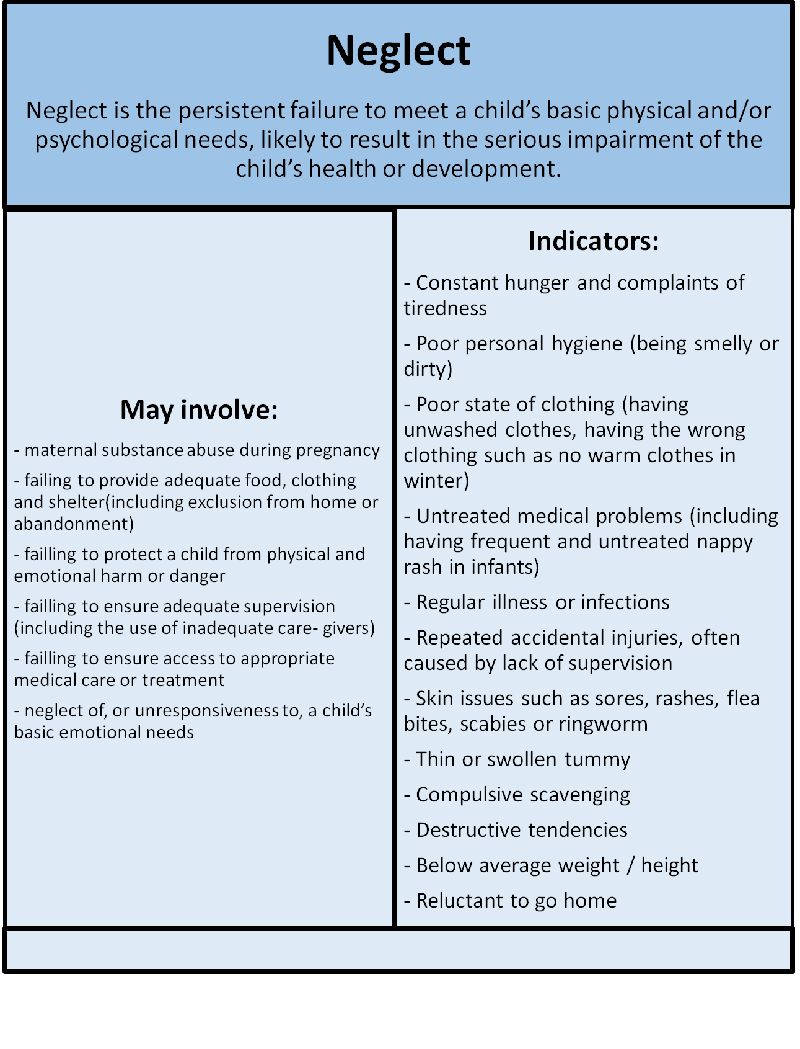
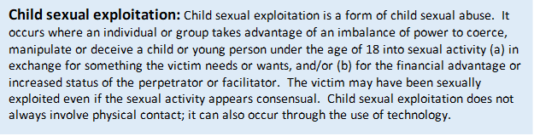
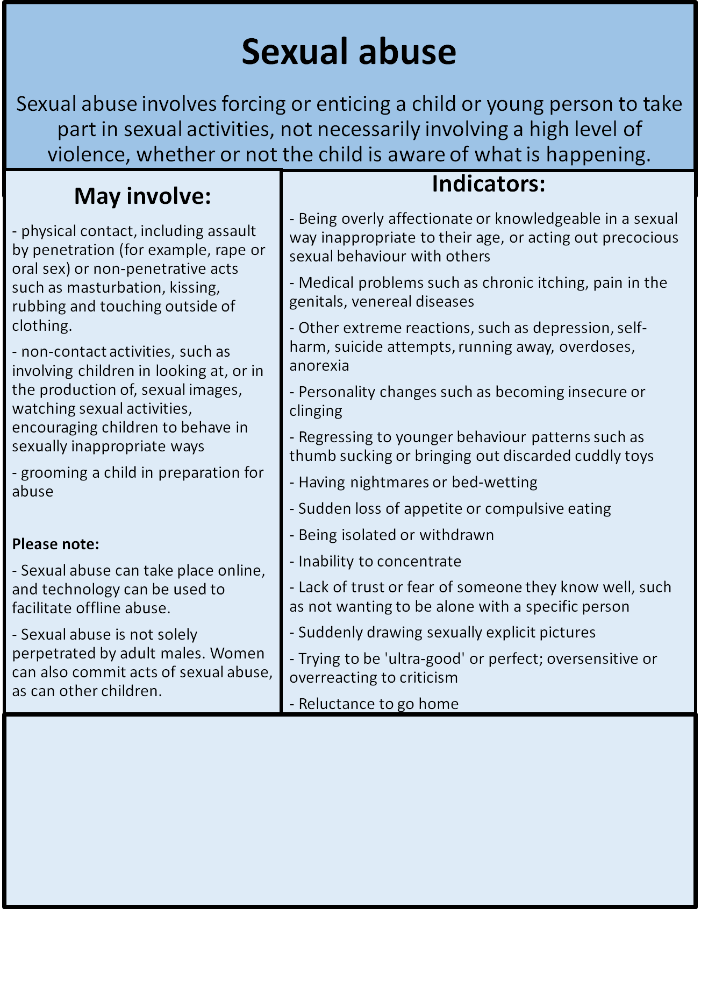

Key areas of safeguarding and child protection risk which might be seen at Babyzone
In addition to the four types of abuse described above, there are key safeguarding issues and child protection risks that are more likely to be seen at Babyzone. These are:
- anxiety, depression
- attention seeking
- bed-wetting, nightmares
or insomnia.
- constant or regular sickness,
like colds, headaches and mouth
ulcers

- eating disorders
- problems in school or trouble learning
- tantrums.
- withdrawal

Domestic abuse
Child trafficking

Criminal exploitation and county lines
c
FGM
Female Genital Mutilation
So-called ‘honour-based’ violence
Faith abuse

c

Appendix B: Safeguarding and child protection flow chart: What to do if you become aware of a safeguarding issue
Where there is not a child protection emergency but the DSL does not have the cooperation of the family to make a referral to the Safeguarding Partnership, the DSL will decide if the police need to be contacted or whether all concerns will be recorded in detail and stored securely. Ongoing support can be given to the family where possible.
The DSL will record details of how the concern was followed up and resolved. The DSL will also make a note of any actions taken, decisions reached and the overall outcome.

The DSL will follow up the referral in line with the local authority safeguarding partnership procedures
If the DSL agrees it is a child protection emergency, they will report immediately to the Police
OR
If it is not an emergency, they will make a referral to the local authority safeguarding partnership with the cooperation of the family member
If you and the DSL agree there is no concern, no further action is required.
If you and the DSL agree there is no child protection issue but there is a cause for concern, the concern will be stored securely with full details including date and time. Provide ongoing support to the family where possible.

Record the concerns on a ‘Child Protection/Family Welfare Concern Reporting Form’ and discuss immediately with the Designated Safeguarding Lead (DSL)
You have a concern about a child’s welfare


Child Protection/Family Welfare Concern Reporting Form
This form is the immediate/offline capture tool; the DSL will transfer its content into MyConcern as the permanent digital record.

Subjects’ name: | Age and DOB (if known):
Name and position of person completing form:

Date and time of incident/concern:

Incident/concern (who/what/where/when?):

Any other relevant information (witnesses, support given etc.)

Action taken:

Reporting person signature: ……………………………………………….. Date:

Designated Safeguarding Lead (DSL) – Response/Outcome:

DSL signature: ……………………………………………………… Date:

